Directions
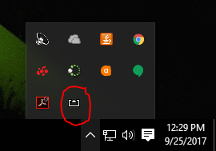

AirServer can be located in the notification area on the bottom right of your desktop.

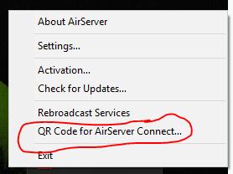

Click on “QR Code for AirServer Connect…”

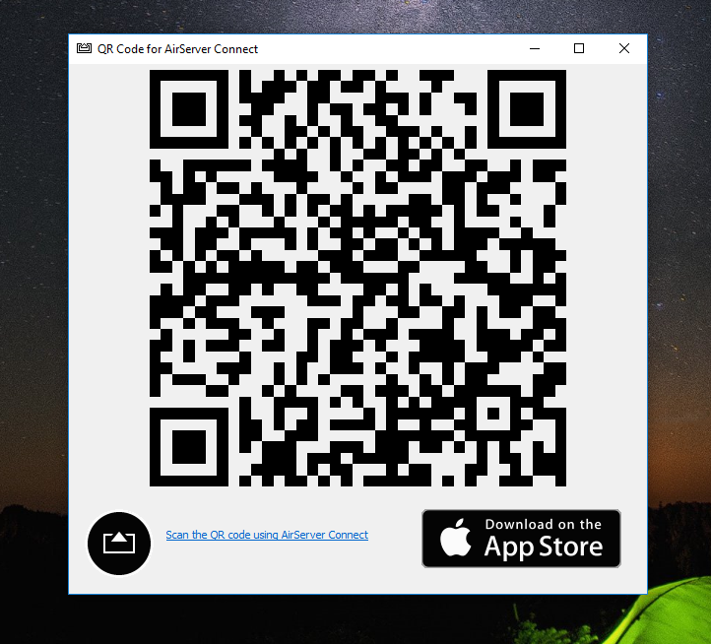

A large QR Code will appear on your desktop. Now, pick up your iPad.

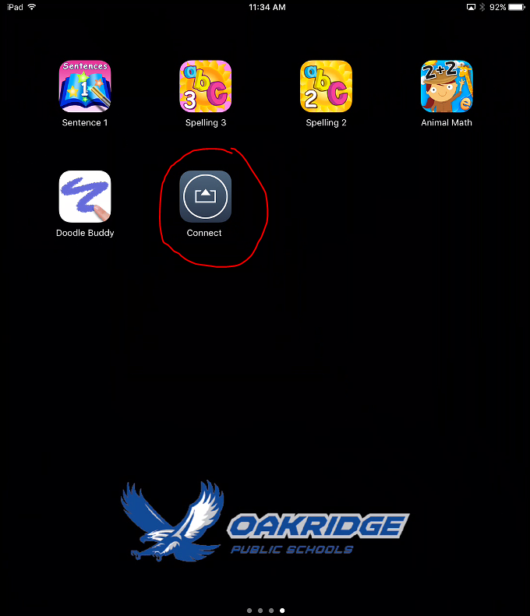

Click on the AirServer Connect App on your iPad.

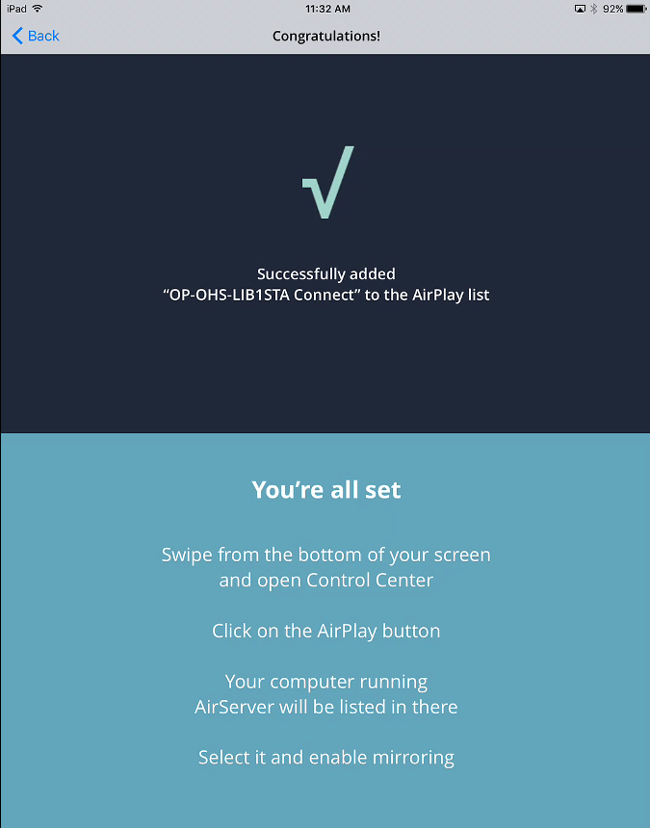

Follow the directions on the screen. You should now see your iPad image on your desktop.

